Content:

1 Content: 1
2 Introduction. 2
3 Step 01: Download & Install JDK 3
4 Step 02: Download&Install LazToApk 4
5 Step 03: Start & Configure LazToApk for the first time 7
6 Step 04: Start Lazarus and install package „CustomDrawn“ 10
7 Step 05: Start SDK-Manager and install API's 13
8 Step 06: Restart LazToApk and start AVD-Manager 20
9 Step 07: Build your first android app 24
10 Troubleshooting: 37
10.1 Where / how to start LazToApk again. 37
10.2 Create a new Android Virtual Device (AVD): 37
10.2.1 List of possible AVD settings: 37
10.3 Update the Android SDK (add new Android API’s) 37
11 Running the demo on your own (real) device: 38
12 Run Lazarus for Android to create your own app for Android: 38
12.1 Use LazToApk: 38
12.2 Create another icon and use that next to the “Normal” Lazarus. 39

Introduction.

04/11/2014

This document is based on “Lazarus and Android.pdf” dated 2014-10-22 created by Delphifreak71.

I used his document to install LazToApk on my Windows 8 system. And made screenshots during the process to help others installing it on Windows 8.
Because I am dutch, some screenshots contain dutch words. Here and there I translated button or message texts in English for better understanding.

The text of my document, is the original text of “Lazarus and Android.pdf”, it was only changed where necessary. Where relevant my comments are with yellow background. Screenshots are all from my installation.

First my system:
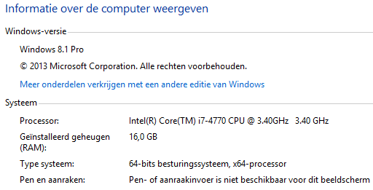

Important Note:
- A)Please remove previous versions before installing a new version.
I Did not do that, everything seems to work. The Demo app runned fine!
- B)Installation path containing “SPACE” char's do still not work.

Lazarus and Android

To create Android Apps with Lazarus (on windows), you need to download and install the following packages. (Warning, this will take at least 5GByte of disk space).

The whole installation&compile process can take up to one hour depending on your hardware and internet connection.

Please precisely follow this instructions, otherwise there is a big change that your final app will not work!

I tested it on Windows 8.1 PRO as administrator.

Thanks for all your work Delphifreak71!

Tineke, aka Mother10.

Step 01: Download & Install JDK

I used the Java SE Development Kit 8u25 from page

http://www.oracle.com/technetwork/java/javase/downloads/jdk8-downloads-2133151.html
I used file: jdk-8u25-windows-x64.exe for windows x64.

It will be installed as a subdir from <C:\Program Files\Java\>.

My Configurationscreen before I start:
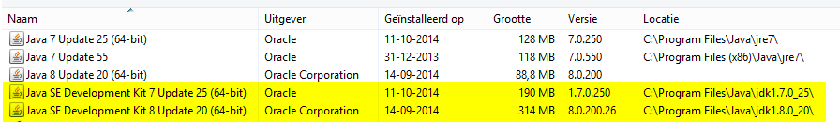

As you can see there are already SDK’s present on my system, which I did not remove before I started. Each one gets installed into its own subdirectory automatically.

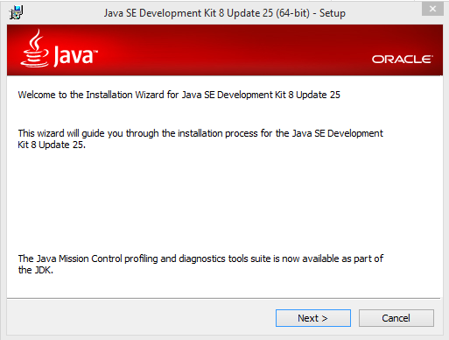

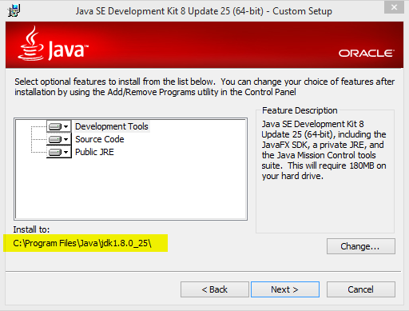 It installs in a subdirectory
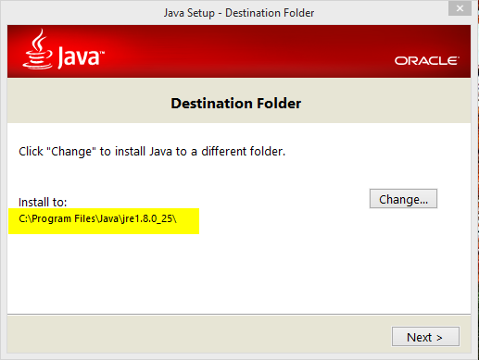

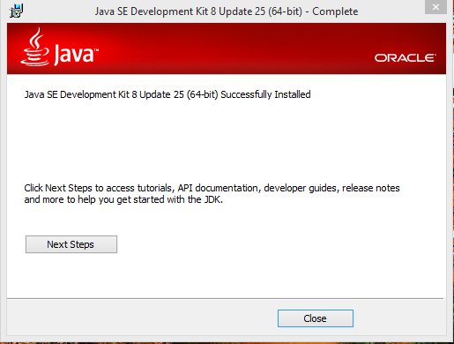
After the installation, Close this screen.

Now my Configurationscreen looks like this:
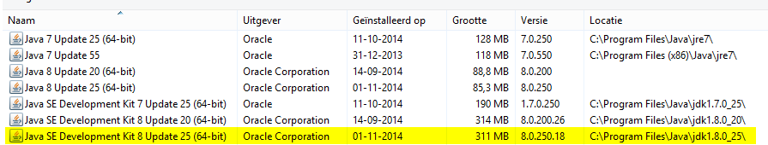
As you can see I have now 3 SDK’s installed. The last one (Update 25, installed on 01-11-2014) is the one we will use.
The other 2 came from a Delphi install and an install of AndroidStudio. Those had different versions.

Step 02: Download&Install LazToApk

LazToApk → Download the setup from here. (sourceforge.net)

When started the setup will automatically:

1.) download ndk.zip to \laztoapk\downloads and then unpack it to
\laztoapk\downloads\ndk
2.) download sdk.zip to \laztoapk\downloads and then unpack it to
\laztoapk\downloads\sdk
3.) download laz4android-43585-New.7z to \laztoapk\downloads and then
unpack to \laztoapk\downloads\laz4android
4.) run \laztoapk\downloads\laz4android\build.bat to recompile Lazarus.

First find your downloaded file, my version was: “setup_laztoapk_alpha_011_experimental.exe” (yellow in the next screen):

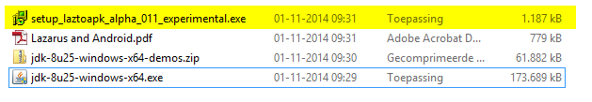
Dubbelclick to start it.

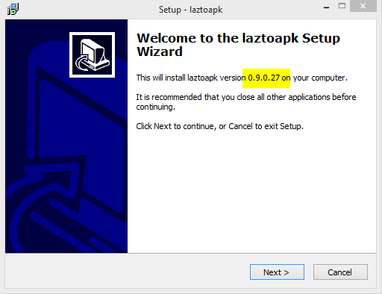 | 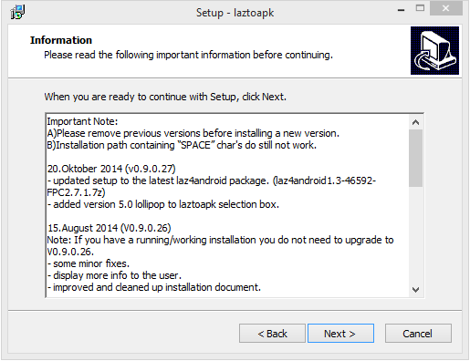
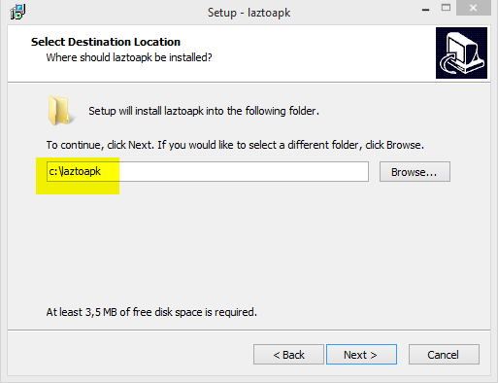 | 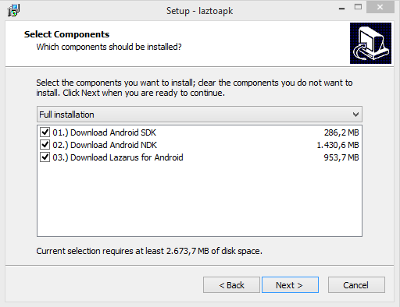
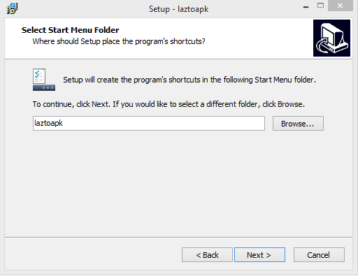 | 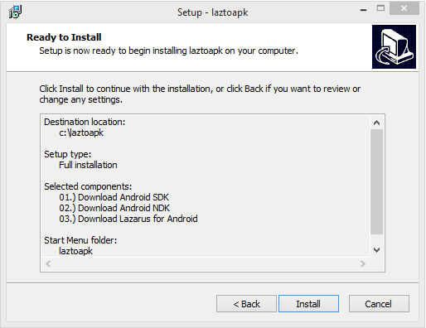
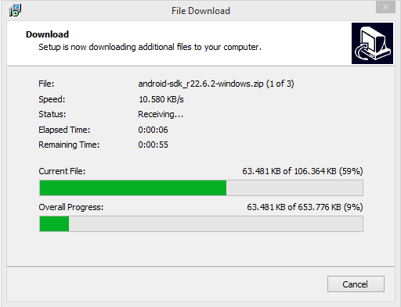 | 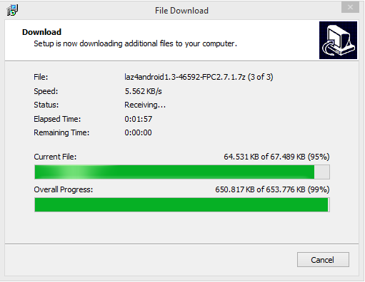

When the overall progressbar reaches 100% we get:
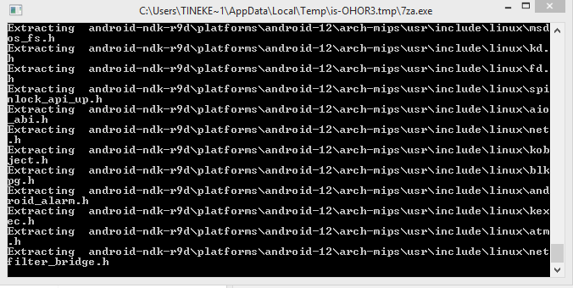

This takes a while before its finished and we get:
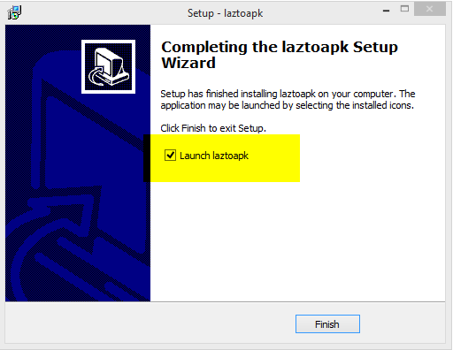

After you press button <Finish>, laz4android get's automatically compiled. This may take a while and look's something like this:

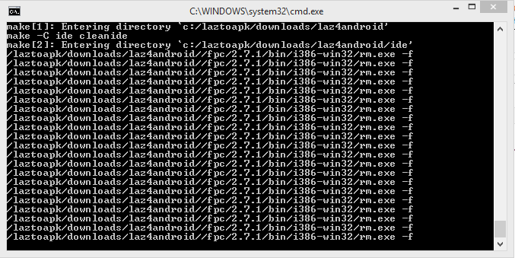 | 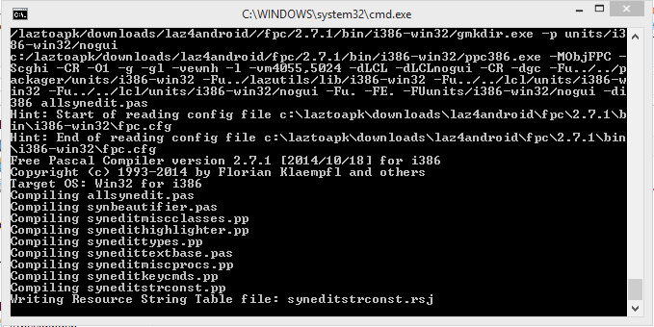

After compiling laz4android on windows 8, my Configurationscreen says about Lazarus itself:
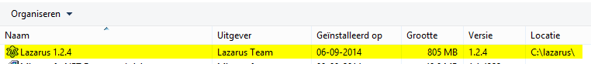
So that means my original Lazarus, installed on 06-09-2014, is still installed and not changed by the new installation and the compilation of laz4android on 1-11-2014.

Step 03: Start & Configure LazToApk for the first time

Now the application LazToApk will be started.
LazToApk will verify if the folder's for JDK,SDK,NDK and the tool lazbuild.exe are available. If not, then path setup dialogs will show up and you must select the correct path manually.

On the first start of LazToApk, you will be asked to select the path to JDK.

According to the configurationscreen my JDK (01-11-2014) was put in the Program files directory:

Setup path to JDK:
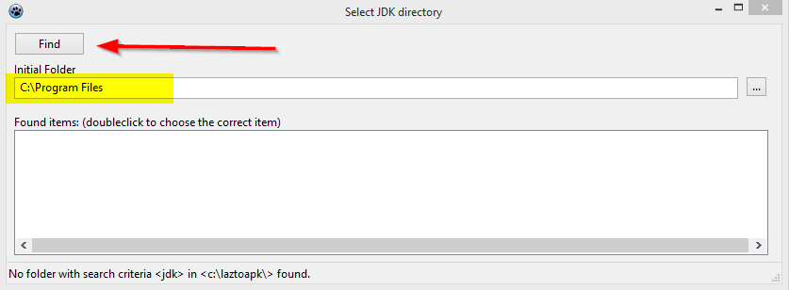
First set the <Initial Folder> (here to my C:\Program Files directory) and then press button <Find>.

On my drive it finds more than one:
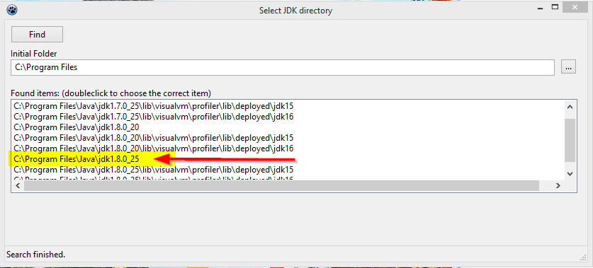
Double-click on the marked entry, the newly installed version, here version 1.8.0_25.

The following path's (for NDK and SDK) should be set automatically by LazToApk. So in most cases it's not needed to set them up manually.

If not, the next screen might popup and you have to
Setup NDK:

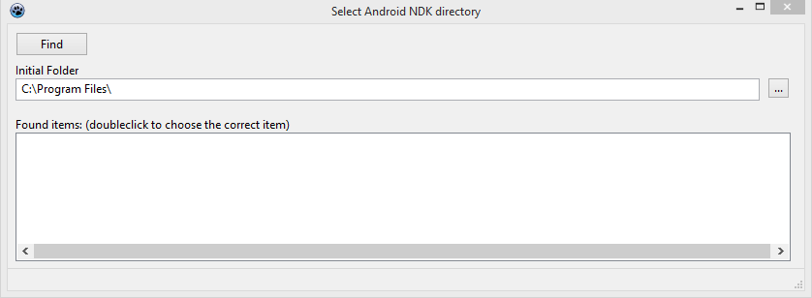
First point it to the download directory of laztoapk like so:

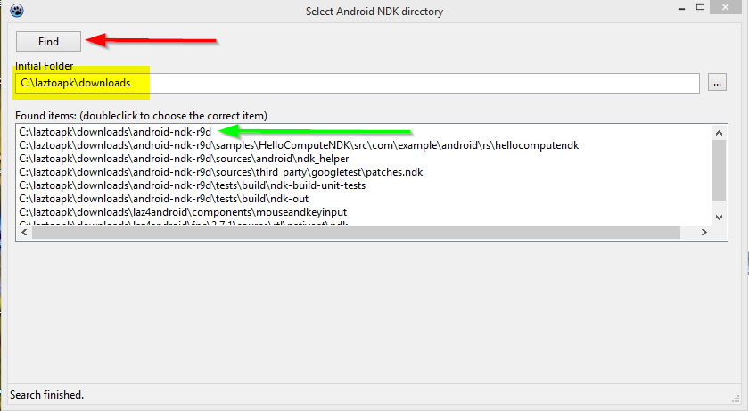
Press find and when the box is filled double-click the one with the green arrow.

Setup SDK:

This path is usually setup automatically. Only the first time you will see the following message.
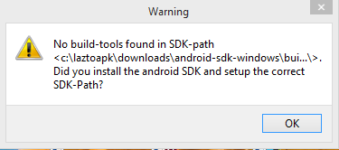
This is fine for now. Just press <OK>.
Finally LazToApk should show up and look like this:
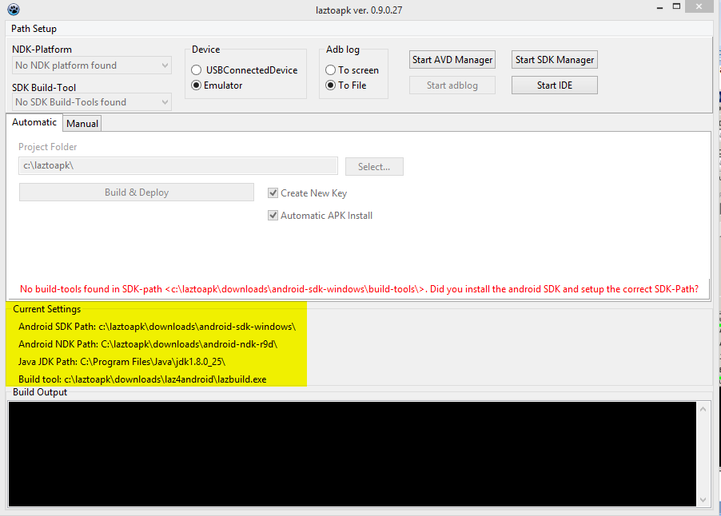

Step 04: Start Lazarus and install package „CustomDrawn“

On the LaztoApk screen press button <Start IDE>.
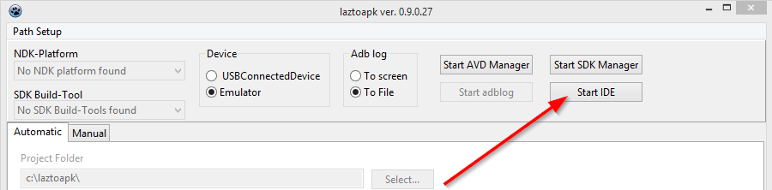

And again on the Lazarus IDE screen:
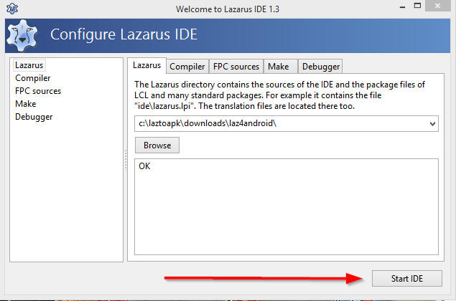

The IDE opens.
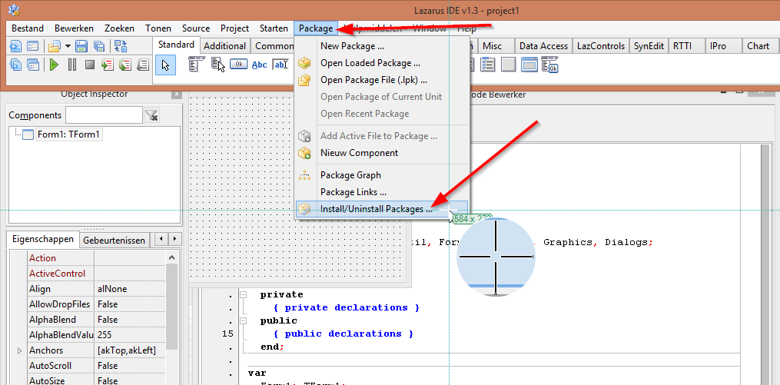
Now we need to install package „CustomDrawn“. Select <Package> <Install/Uninstall Packages>.

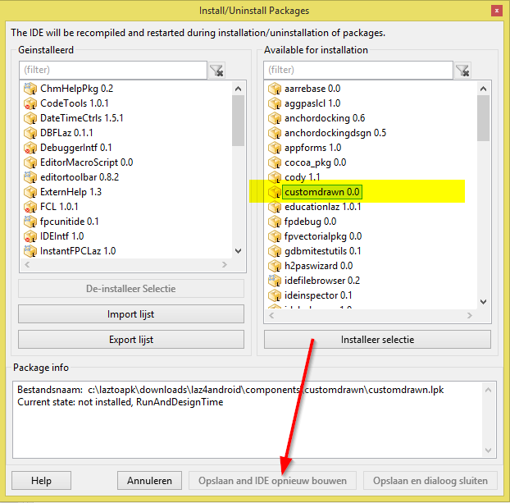
Double-Click on „CustomDrawn“ Package (The “Save and Rebuild IDE” -button is still disabled, see arrow)

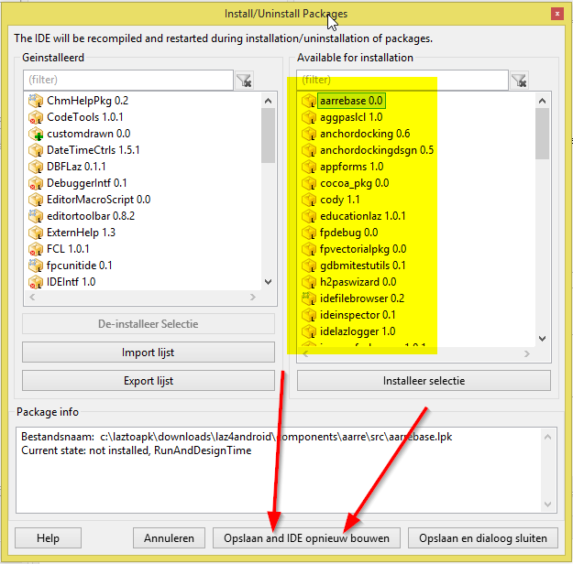
Now the button is enabled so click <Save and rebuild IDE>. (which is “Opslaan en IDE opnieuw bouwen” in dutch)

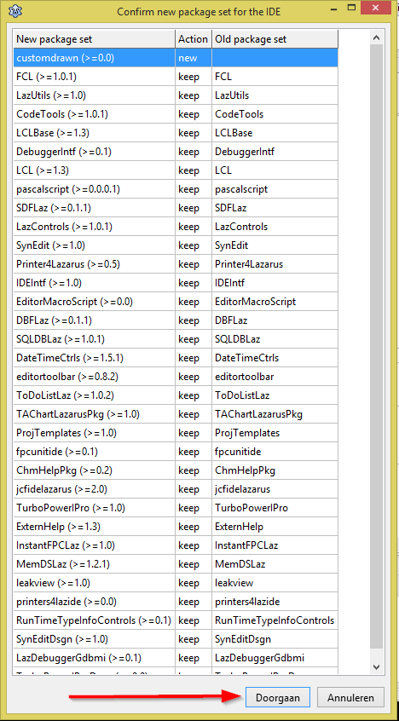
It wants you to Confirm (“Doorgaan”). Press Confirm and wait for it to finish.

After the IDE has been rebuilt, you have to exit Lazarus, but on my system, after compiling, it looks like Lazarus closes and opens itself automatically. To be sure I explicitly exited the Lazarus IDE.

Step 05: Start SDK-Manager and install API's

Now LazToApk will look like this.

It's time to start the <SDK Manager> by pressing its button.
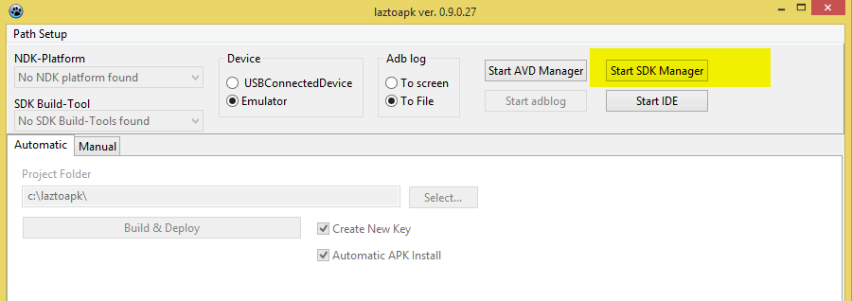

When the Android SDK manager opens, you can shortly see a green bar at the bottom of the screen where it is loading / updating SDK package statuses.

When it is finished my screen looked like this:

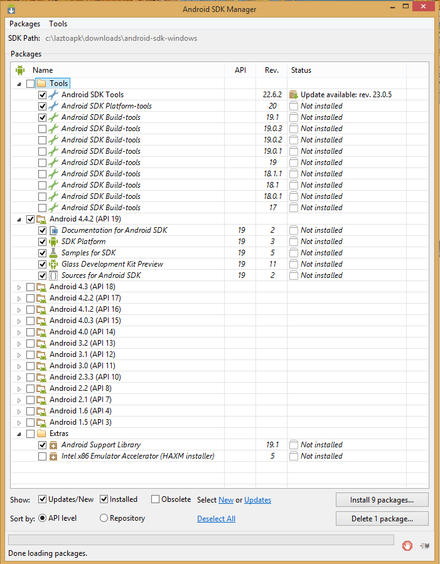

Now make sure the yellow selections are as follows: (the green ones were already selected when the screen opened for the first time)

( you can try some other's but I did not test with other version's!!!!)

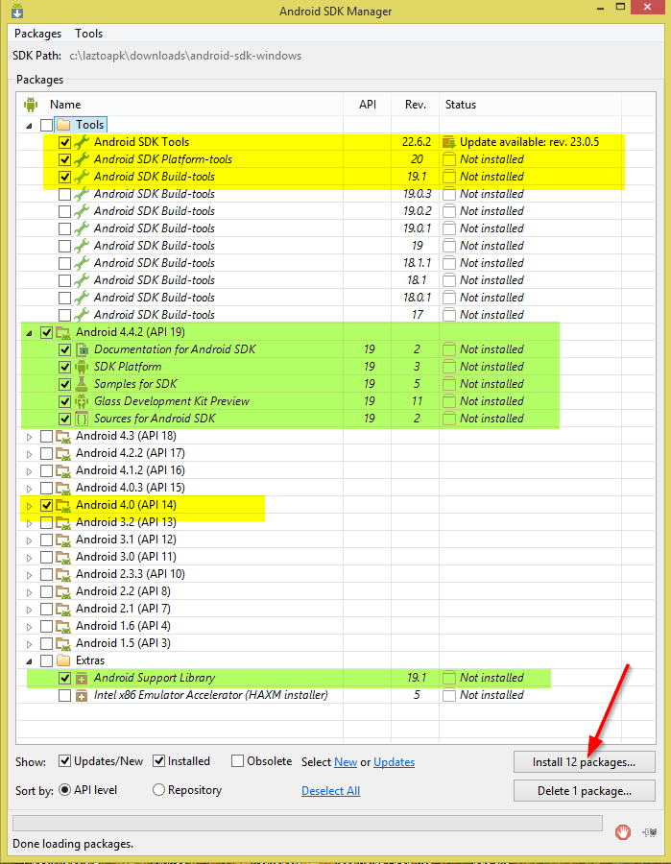
The number of packages on the install button may vary depending on your system)
Now press that install button.

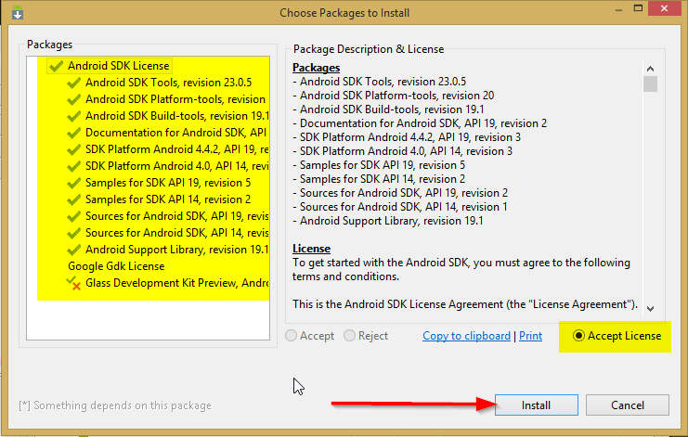
Make sure you accept the Licenses and press Install.
This will take a while.

Some of the screens you might see:
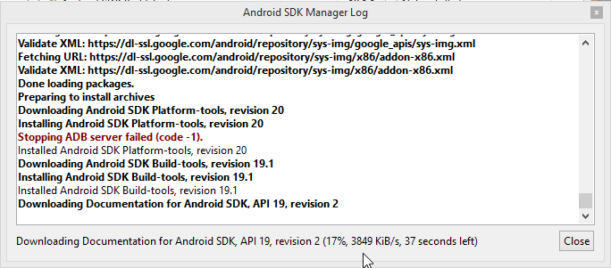
This is the logscreen.

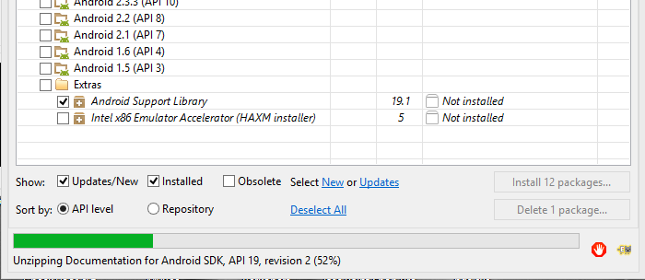
The progress bar on the Android SDK Manager screen.

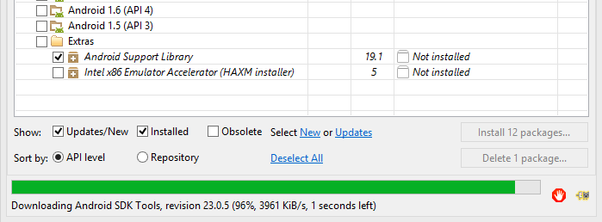
Almost done.

The installation is finished, when the following Dialog shows up.
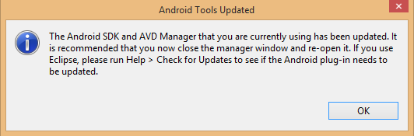
Attention:
Before continuing, I first saved the logfile windows contents, so in case of trouble I could see if and where things might have gone wrong!!:
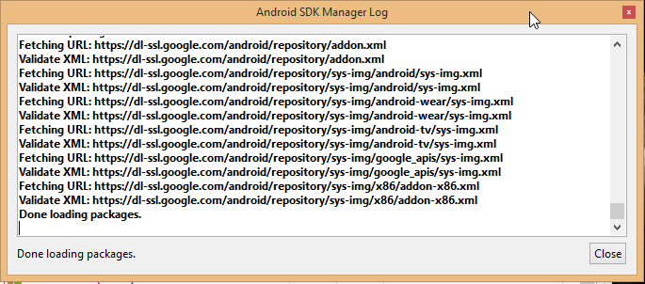

The screen has no save button:
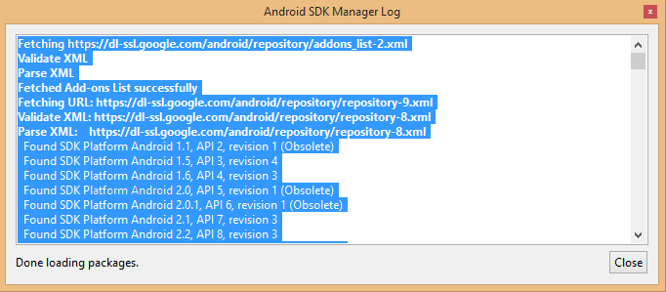
But selecting it with the mouse and giving CTRL+C, and pasting in notepad did the trick. Save it from there.
Now close the Android SDK Manager Log window.

Close SDK Manager and start again:
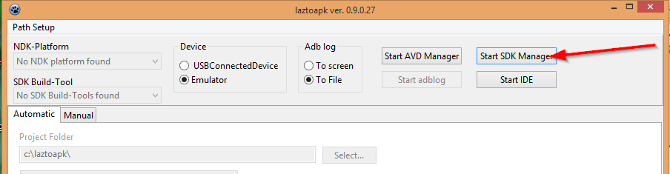
This is how it looks before I did anything:
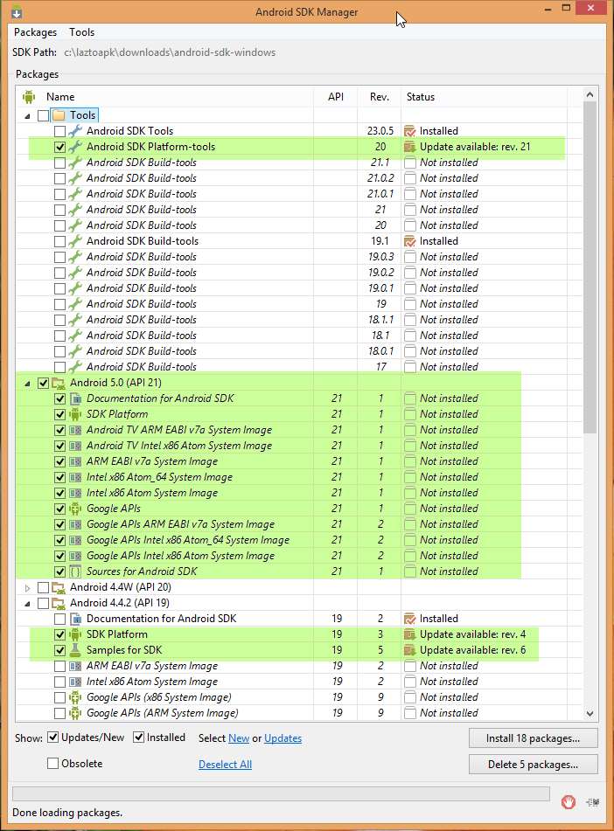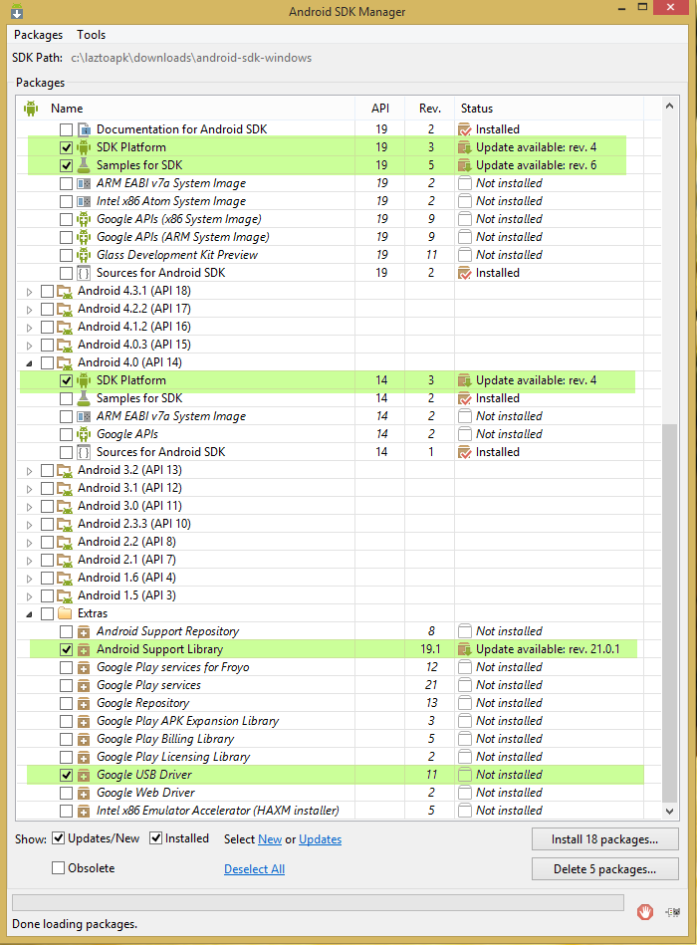
Upper half.... and the lower screen half after some scrolling...:

The green ones were selected for me already. In the next screen shots the one I selected is in yellow:
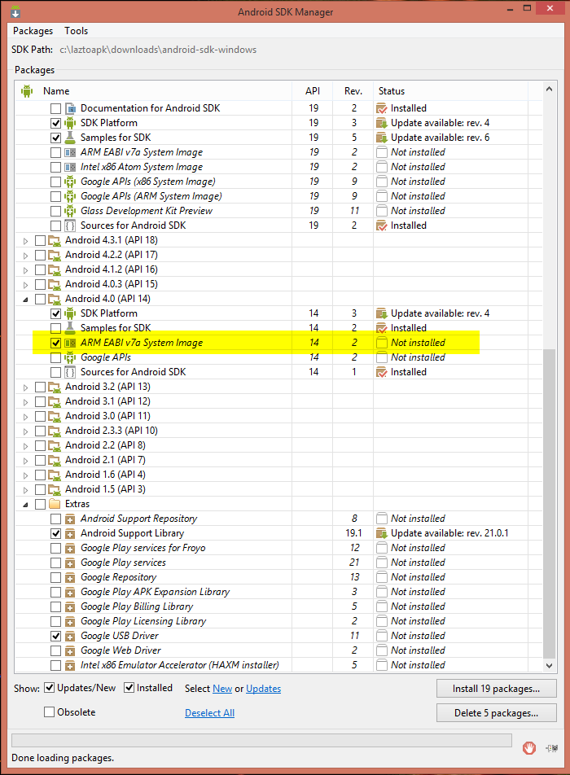 Leave the others deselected.
Press the Install button.
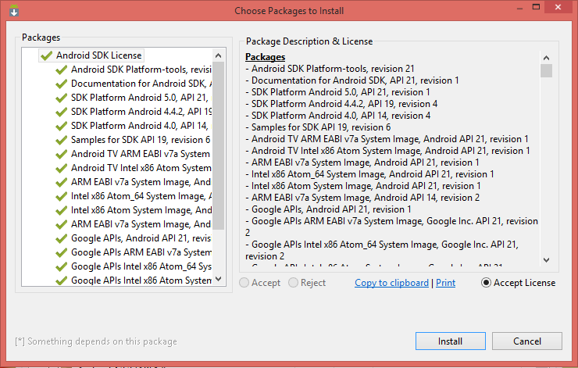
Accept the licenses and Install.

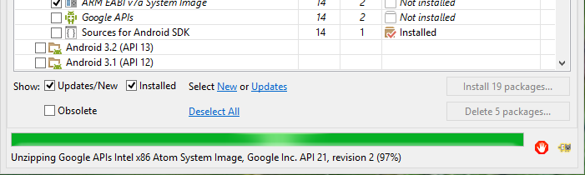
Almost done......
After everything is installed there is no message just this updated screen:
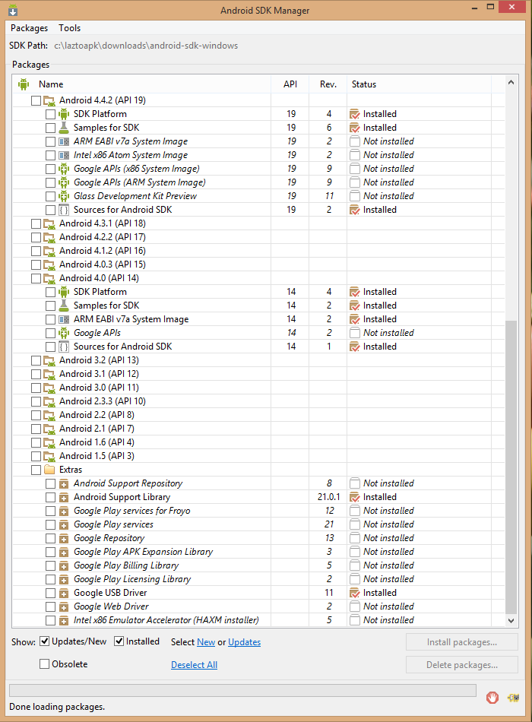
Installation of SDK tools is now finished. Please close the SDK Manager.

Step 06: Restart LazToApk and start AVD-Manager

Close LazToApk and start LazToApk again. (you find the icon for LazToApk on your desktop)
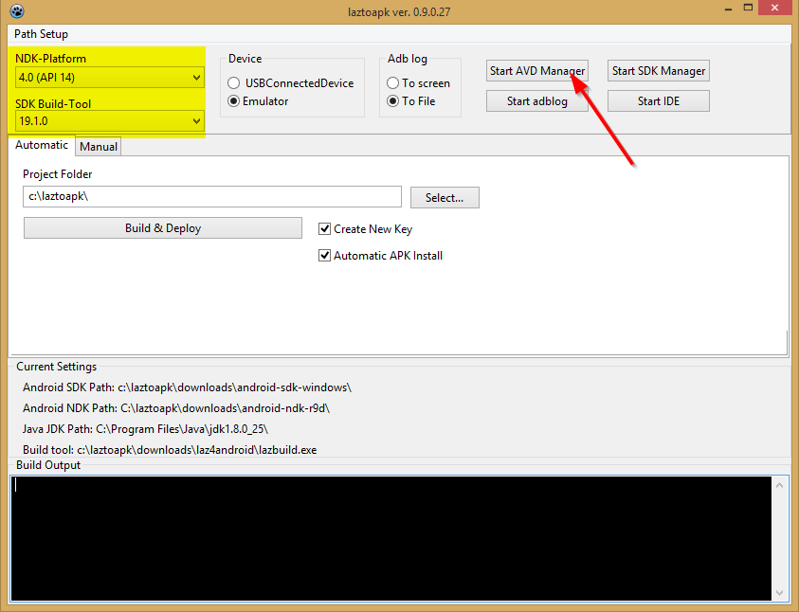
Select <NDK-Platform> 4.0(API14) and press button <Start AVD Manager>

Setup a new virtual android device.

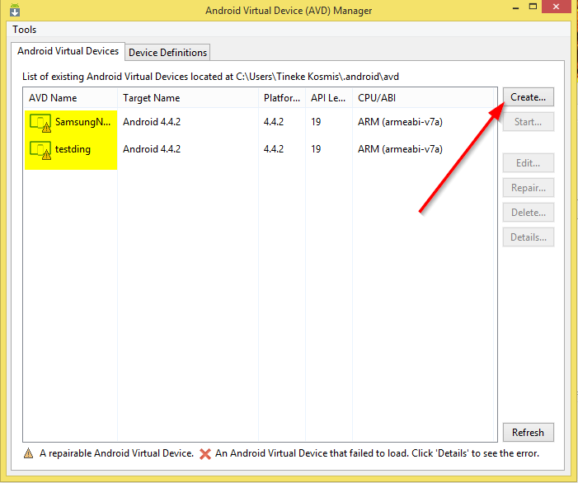
I already had 2 Virtual devices from some other experiments.
Press button Create:

Then choose the following setup:
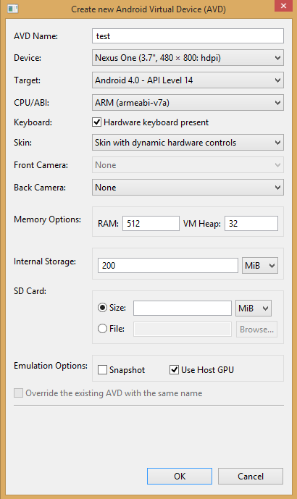
Press OK to create the virtual device.
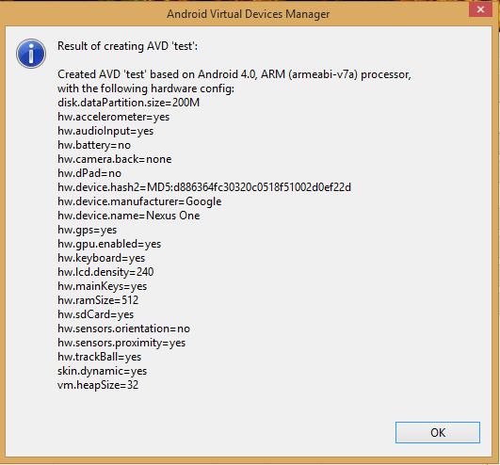 Press OK on this status screen.

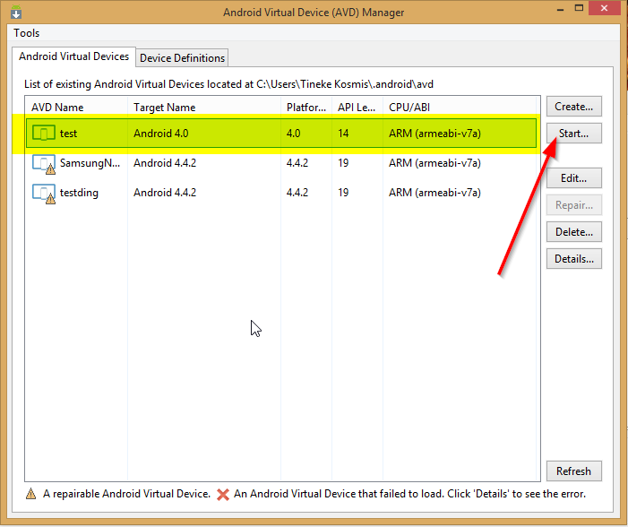
Select the device we just created and press button <Start> to start the virtual android device.
Another screen pops up.
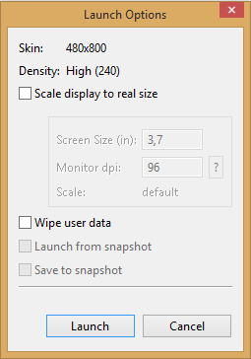
Just press Launch.

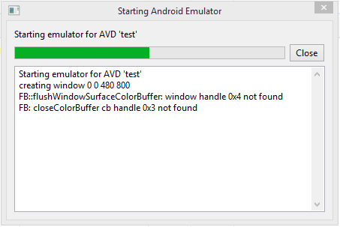
A screen pops up. At that moment I did not realize this screen had errors. That’s because it was immediately covered with the following starting emulated device screen:
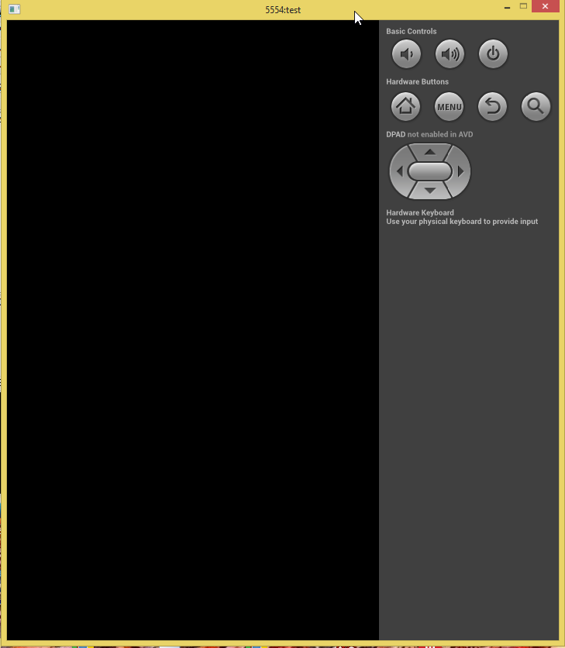
I had read elsewhere that it might take some minutes to start an emulated device so even when the screen did not look as expected, I went on with step 7. The screen should have looked like this:
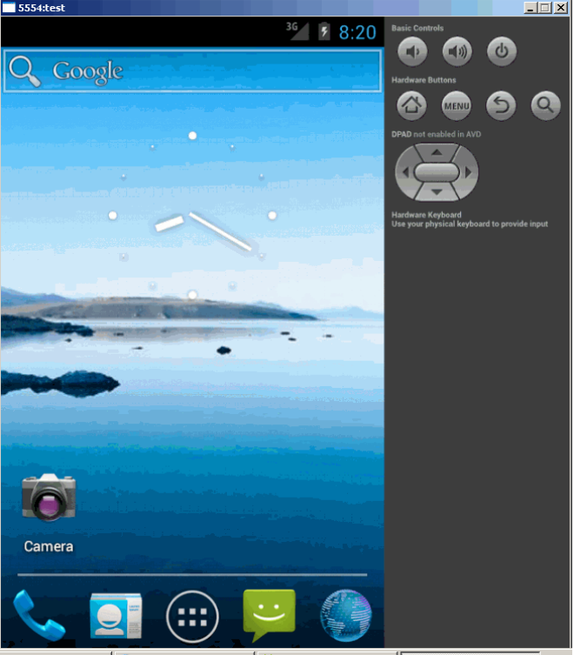
So if yours does not look like it should at this point, go back and correct it first.

Step 07: Build your first android app

Go back to the LazTo Apk screen, and press button „Select“.
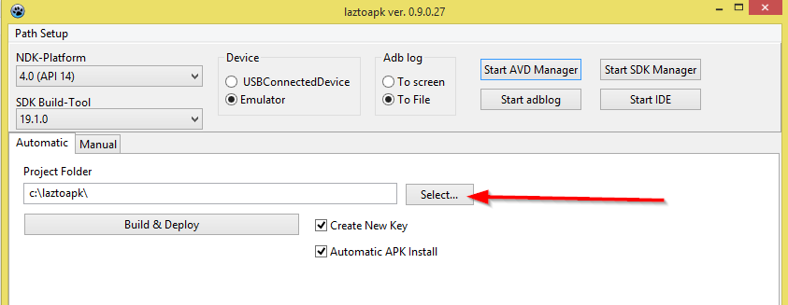
Select the folder „projects“ and press button „Create new folder“.
But on my system there seemed to be no folder Projects under “laztoapk”, so I first had to create one, then it looked like this:
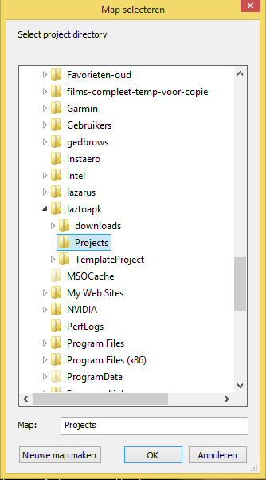

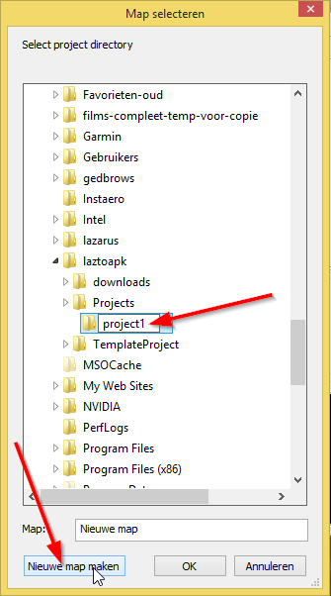
Now create a new folder „project1“ inside “Projects”.
(“Nieuwe map maken” is the dutch version of the button “Create new folder”)
Now select this new folder and press button <OK>. Your screen should look like this now:
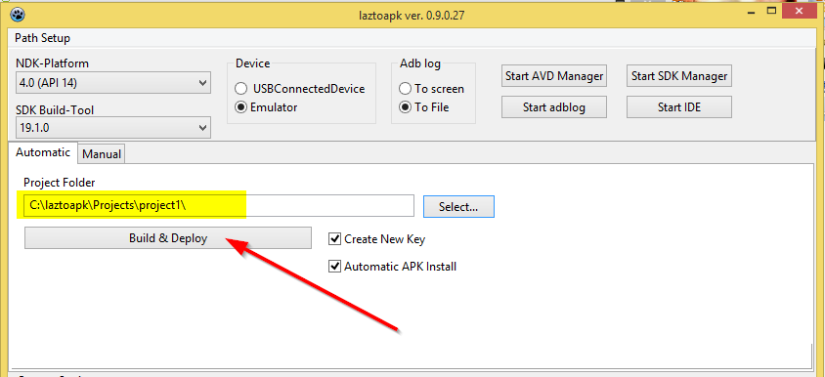Fiels “” now Field “Project Folder” now has the correct path to project1, click Build & Deploy.

The following screen appeared:

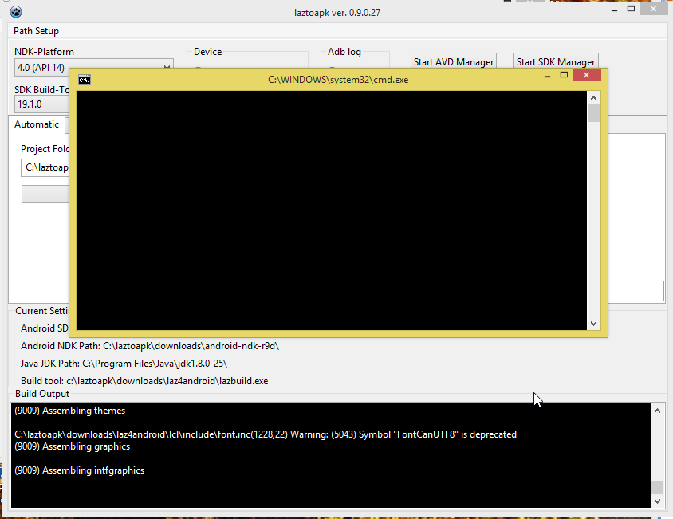
After a short while I got:

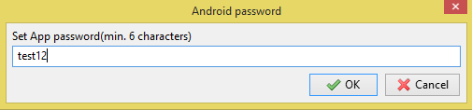
On this screen define a password for your app and press button <OK>.

Instead of the expected information screen I got:

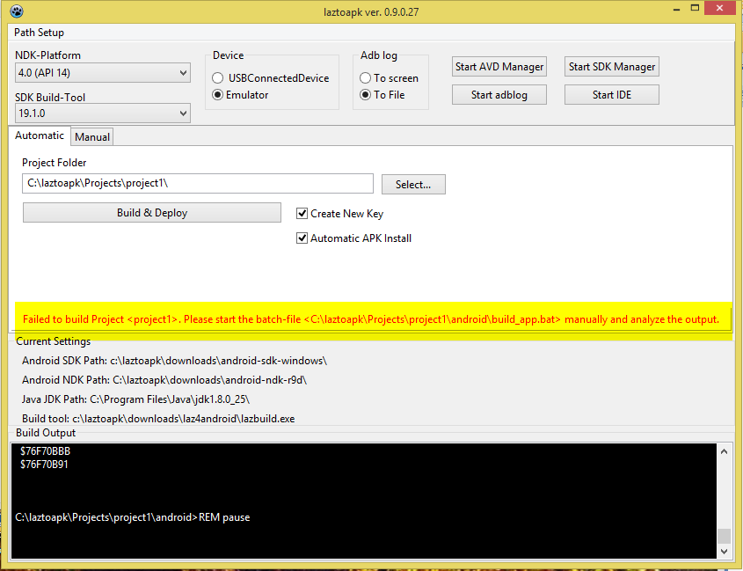
An Errormessage appears telling me I have to manually run a batfile.

I don’t do that, I just clicked “Build & Deploy” again.

Now I get the correct informationscreen:
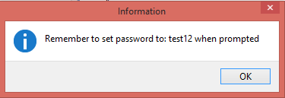

I press OK and get:

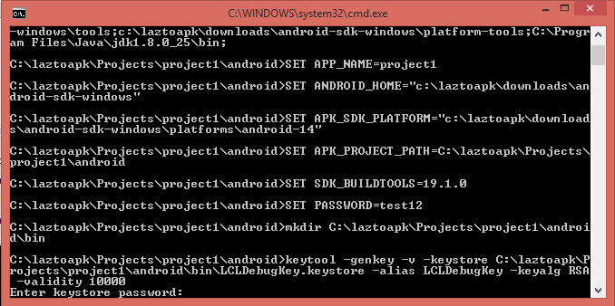
Enter password and press enter. (password stays hidden)

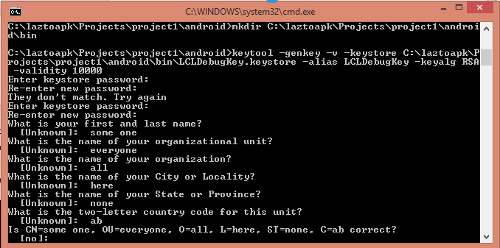
It wants you to fill in much more things...... so I did with some fancy information.

Now the emulator on my system did not finish as it should. Because I had no idea why it went wrong, I got back to laztoapk and pressed “Build & Deploy” again. Then this is what I see:
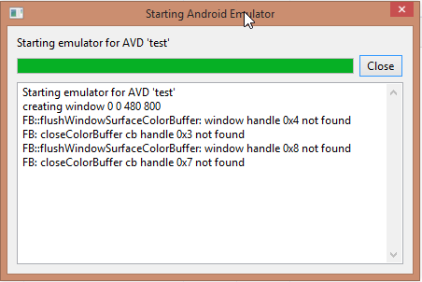
I checked the SDK manager from the laztoapk screen. Compared it to another SDK manager on my pc (the Delphi one) and saw that the yellow line in the screen below is not installed for laztoapk:
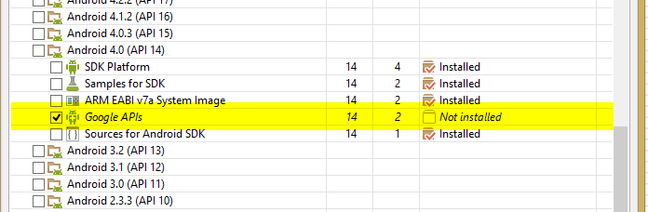
It seems the Google apis voor API 14 are missing. So I mark the line and install it from the SDK manager.

Now I exit and restart laztoapk to be sure and do “build en deploy”again:
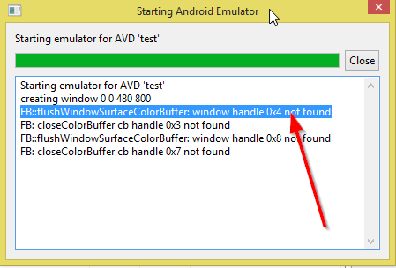
Because during the actions above, this logscreen was hidden underneath another one all the time, now for the first time I see there is an error message.
Pasting the blue text in Googles search box I find:

Host GPU is only supported for AVD devices that are using API 15 or later.

I remember there was a “HOST GPU” checkmark when creating the virtual test device with AVD manager and the test is meant for API14.
So I go back to AVD manager (from the laztoapk screen), to change the testdevice we just created, but I make sure the parameters now are as follows:
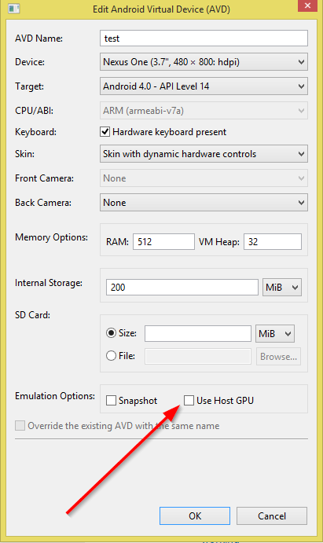 NO checkmark for Host GPU.
Press OK:
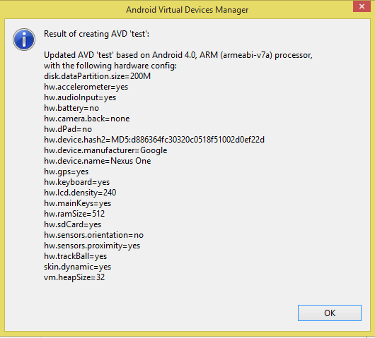
Everything seems fine. So I start the changed testdevice:
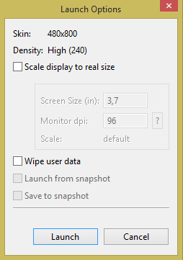

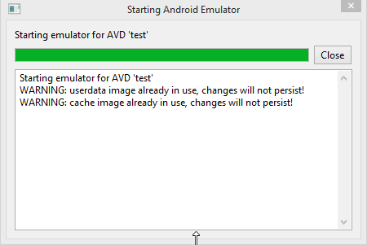
I make sure I can see this LOG screen. NO MORE ERRORS.

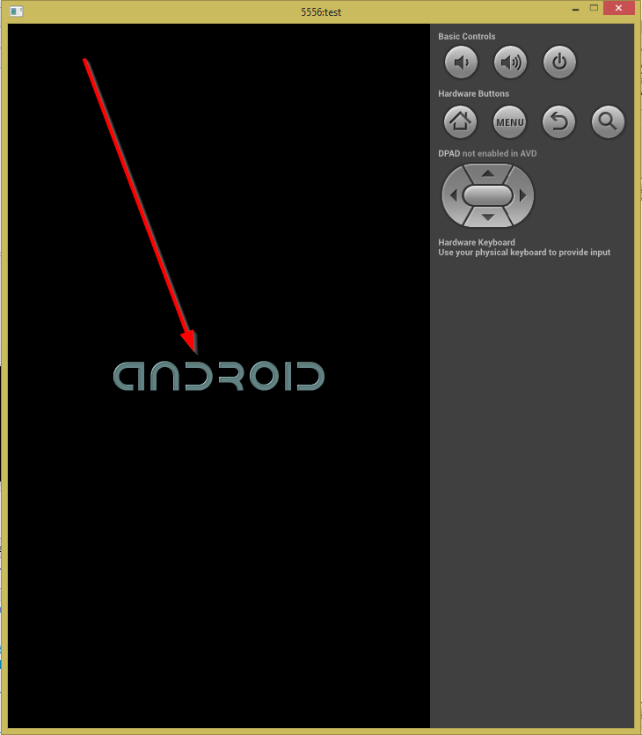
Now Look it seems to start! But this is how far it gets. Still not right.
What I forgot was to close the already running other device so I get an error message in a popup screen. I close both emulated devices. And start the testdevice again. (From AVD manager)

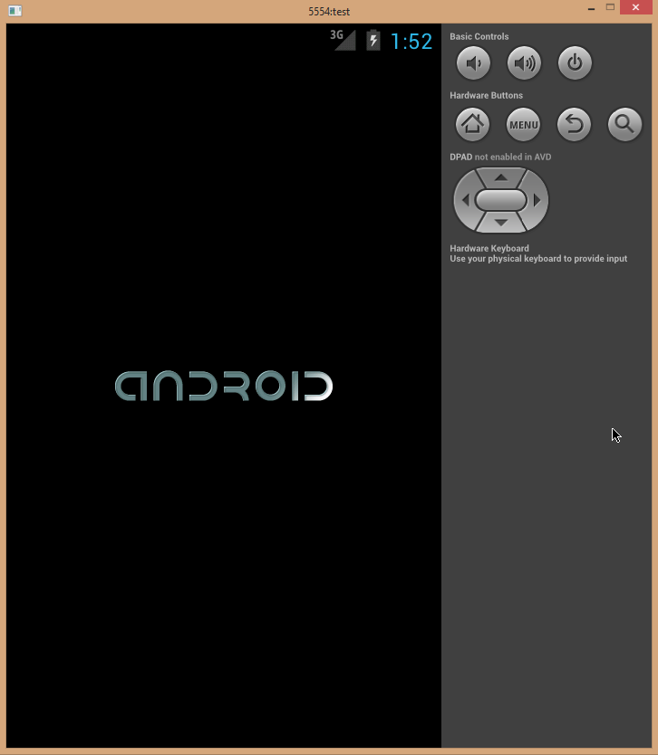
There we are, even a little clock is now visible. But this is how far it gets.
I click the little grey Home button on the right side of the emulator......
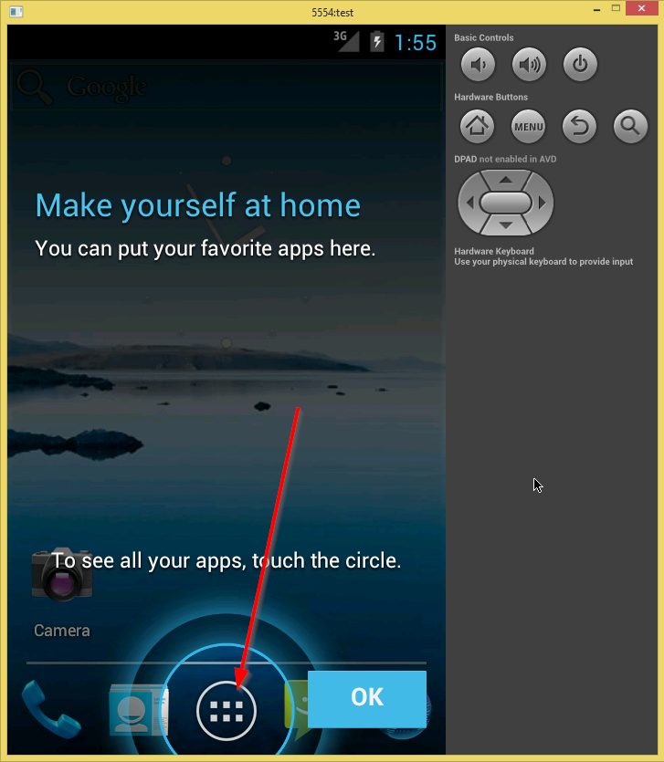
Finally...... the emulator is running fine now!
The demo-icon is not visible. Because I don’t know this device I try swiping left and right. No demo app. Then I click applications (that icon looks familiar, see the arrow)
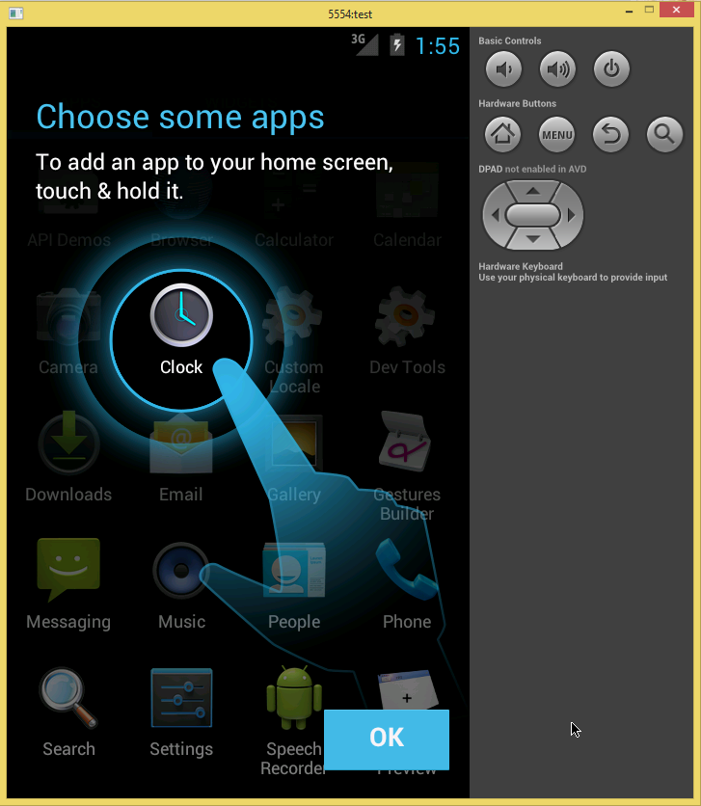
Cant find the demo app anywhere.
So I am going to try another sequence. First I close the virtual test device.
Next I do “Build en Deploy” again. Only when that is finished, I start the emulated virtual test device.
YES it seems to work, because now I get the correct screen but its locked:
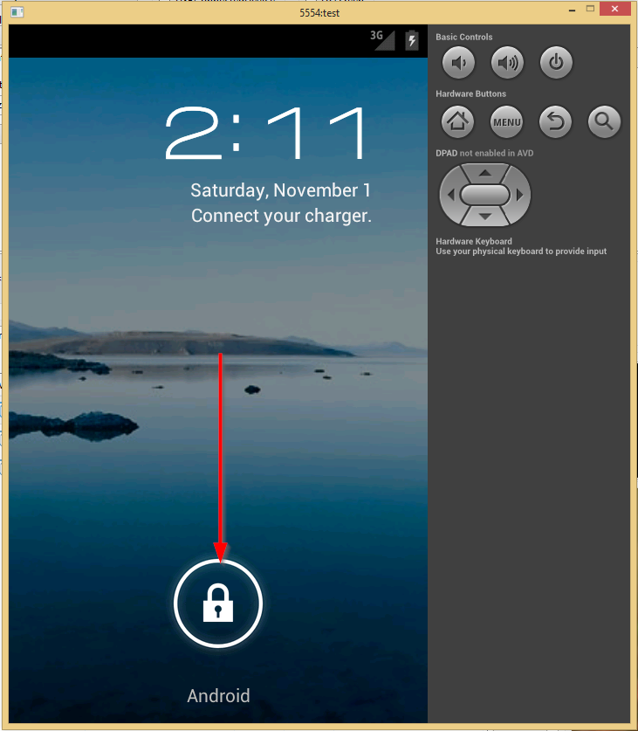

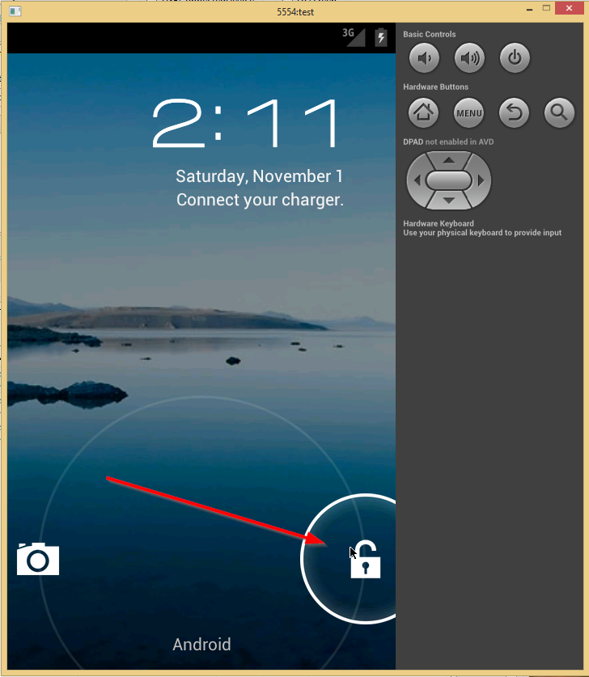
You can move the lock to the right of the screen.
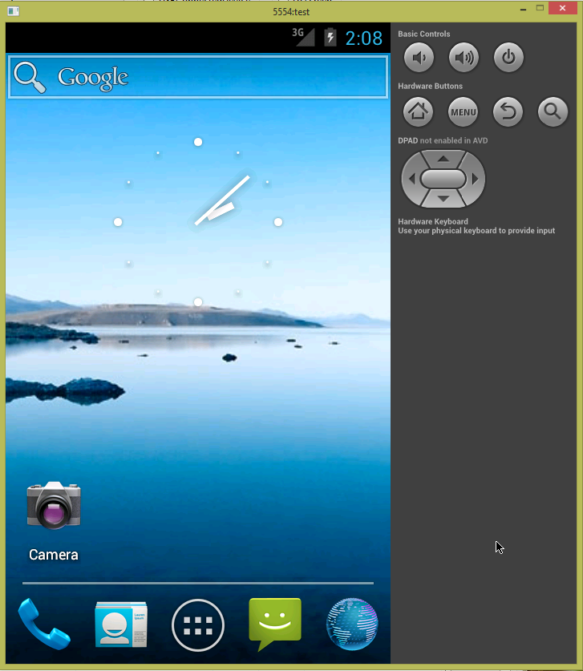
Now this is what we should see.
Press the apps icon on the bottom of the screen: (icon in the middle)

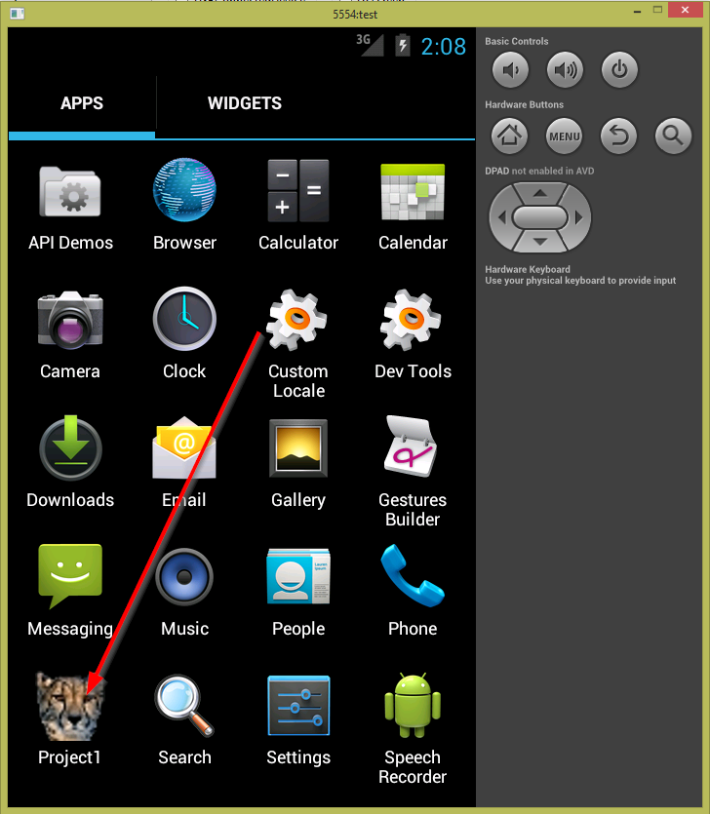
There is our demo app!!! Click on it.
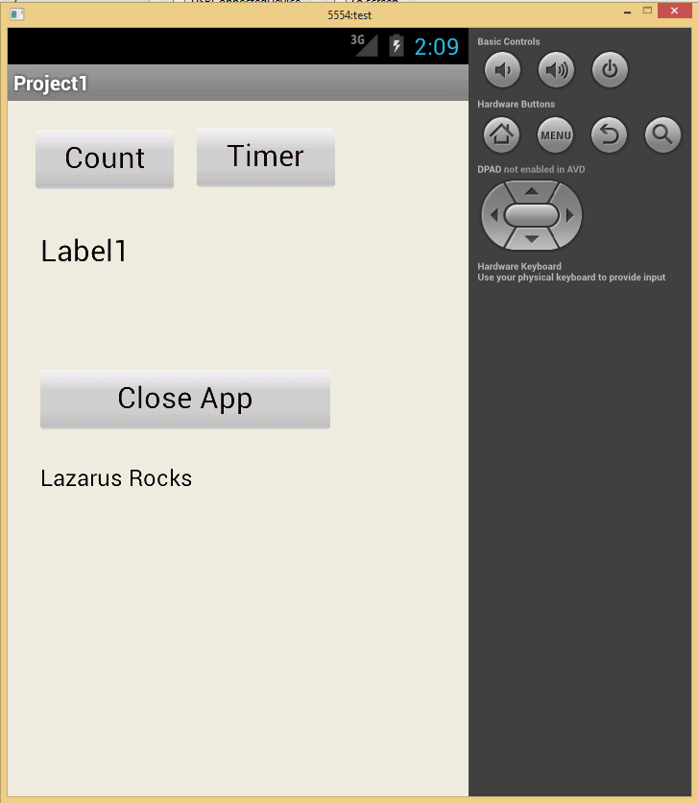
The app is running

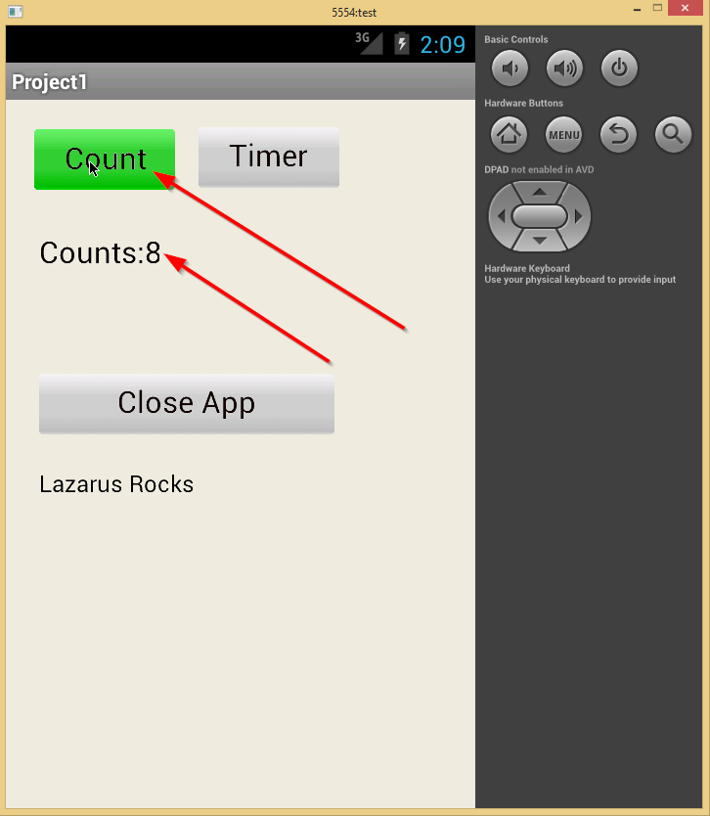
Test the app.

Congratulations!!!!!!!!!!!!!!!!!

Troubleshooting:

Where / how to start LazToApk again.
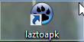
After installation of LazToApk it creates an icon on your desktop. You can restart it from there. When you are going to use it often, put it on the taskbar (right-click and choose “Add to taskbar”, or drag it to the taskbar)

Create a new Android Virtual Device (AVD):
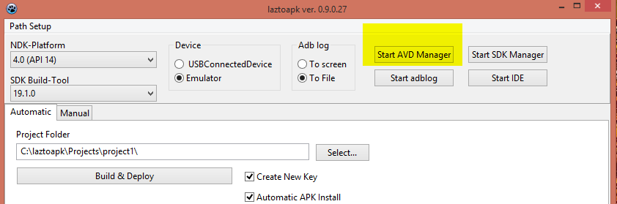
Start laztoapk and click on the button “Start AVD Manager”.

List of possible AVD settings:
You can find a list of possible AVD settings at:

http://www.avd-settings.de/

Update the Android SDK (add new Android API’s)
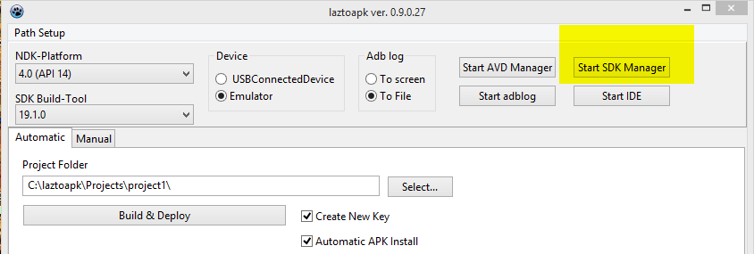
Start lazToApk and click on button “Start SDK Manager”.

Running the demo on your own (real) device:

Make sure your physical device has USB debugging on!! (search google to find out how to do that)

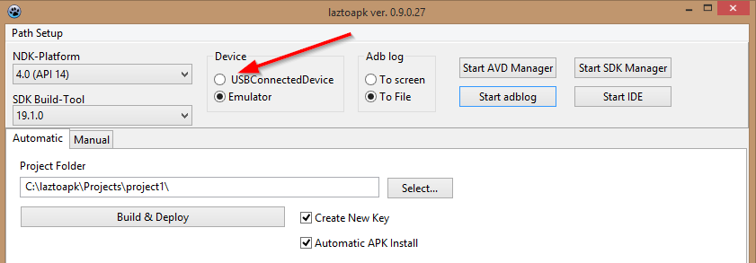
Start LazToApk and place the check at “USBConnectedDevice” like so:

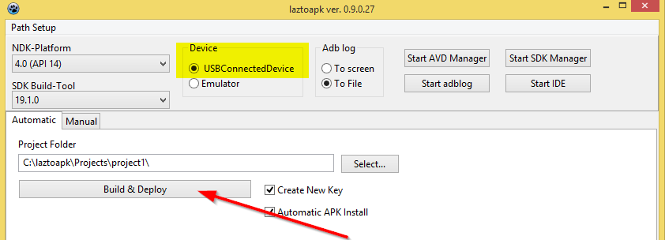
Then press “Build & Deploy”.

Run Lazarus for Android to create your own app for Android:

For this you cannot use the “Normal” Lazarus that might also be present on your system. That one does not have the correct components and stuff added.

Use LazToApk:

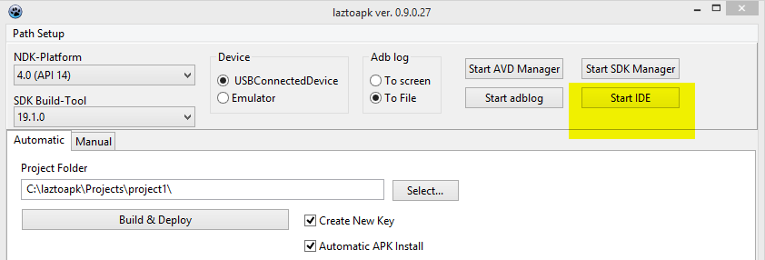
Use button “Start IDE” on the LazToApk screen.

Create another icon and use that next to the “Normal” Lazarus.

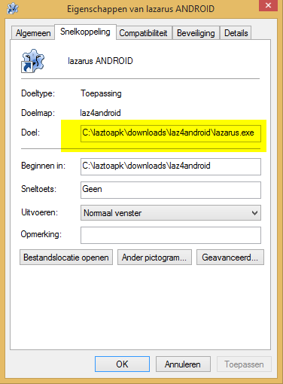
Find the directory:
C:\laztoapk\downloads\laz4android
Create an icon for the file lazarus.exe. This is the Lazarus with which you can create Android app’s.
You can have both versions of Lazarus on your system. At least for me it works fine.

